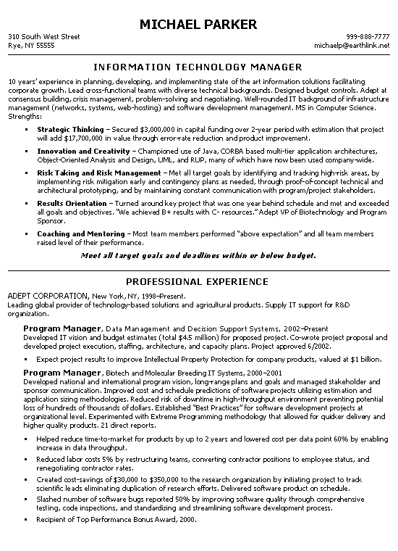
310 South West Street Rye, NY 55555
MICHAEL PARKER
999-888-7777 michaelp@earthlink.net
INFORMATION TECHNOLOGY MANAGER
10 years' experience in planning, developing, and implementing state of the art information solutions facilitating corporate growth. Lead cross-functional teams with diverse technical backgrounds. Designed budget controls. Adept at consensus building, crisis management, problem-solving and negotiating. Well-rounded IT background of infrastructure management (networks, systems, web-hosting) and software development management. MS in Computer Science. Strengths:
Strategic Thinking - Secured $3,000,000 in capital funding over 2-year period with estimation that project will add $17,700,000 in value through error-rate reduction and product improvement. Innovation and Creativity - Championed use of Java, CORBA based multi-tier application architectures, Object-Oriented Analysis and Design, UML, and RUP, many of which have now been used company-wide. Risk Taking and Risk Management - Met all target goals by identifying and tracking high-risk areas, by implementing risk mitigation early and contingency plans as needed, through proof-of-concept technical and architectural prototyping, and by maintaining constant communication with program/project stakeholders. Results Orientation - Turned around key project that was one year behind schedule and met and exceeded all goals and objectives. "We achieved B+ results with C- resources." Adept VP of Biotechnology and Program Sponsor.
Coaching and Mentoring - Most team members performed "above expectation" and all team members raised level of their performance.
Meet all target goals and deadlines within or below budget.
PROFESSIONAL EXPERIENCE
ADEPT CORPORATION, New York, NY, 1998-Present.
Leading global provider of technology-based solutions and agricultural products. Supply IT support for R&D organization.
Program Manager, Data Management and Decision Support Systems, 2002-Present Developed IT vision and budget estimates (total $4.5 million) for proposed project. Co-wrote project proposal and developed project execution, staffing, architecture, and capacity plans. Project approved 6/2002.
Expect project results to improve Intellectual Property Protection for company products, valued at $1 billion. Program Manager, Biotech and Molecular Breeding IT Systems, 2000-2001
Developed national and international program vision, longrange plans and goals and managed stakeholder and sponsor communication. Improved cost and schedule predictions of software projects utilizing estimation and application sizing methodologies. Reduced risk of downtime in high-throughput environment preventing potential loss of hundreds of thousands of dollars. Established "Best Practices" for software development projects at organizational level. Experimented with Extreme Programming methodology that allowed for quicker delivery and higher quality products. 21 direct reports.
· Helped reduce time-to-market for products by up to 2 years and lowered cost per data point 60% by enabling increase in data throughput.
· Reduced labor costs 5% by restructuring teams, converting contractor positions to employee status, and renegotiating contractor rates.
Created cost-savings of $30,000 to $350,000 to the research organization by initiating project to track scientific leads eliminating duplication of research efforts. Delivered software product on schedule. Slashed number of software bugs reported 50% by improving software quality through comprehensive testing, code inspections, and standardizing and streamlining software development process. Recipient of Top Performance Bonus Award, 2000.

